Analytical Problem Solving: Delivery Robot in a 5×5 Warehouse

Problem Setup
Cells are written as (row, column). The robot starts at S = (1,1) and must reach G = (5,5). Blocked cells (shelving units, marked X) are (2,2), (2,3), (3,3), (4,2) and (4,4). Moves: Up = row − 1, Down = row + 1, Left = column − 1, Right = column + 1; every move costs 1.

 | c1 | c2 | c3 | c4 | c5
r1 | S
r2 |  | X | X
r3 |  |  | X
r4 |  | X |  | X
r5 |  |  |  |  | G

Tie-breaking convention used in all traces: neighbours are generated in the order Up, Down, Left, Right. Both searches use a visited/explored set so that no cell is entered twice.

PEAS Description

Component | Description
Performance measure | Deliver the package at (5,5) (task success).  Minimise path cost, i.e. the number of moves (time/energy). Never enter a blocked cell or leave the grid (safety, no collisions).
Environment | 5×5 discrete grid warehouse with 5 blocked cells; 20 free cells. Fully observable and known map, deterministic, static (shelves do not move), single agent, sequential, discrete.
Actuators | Drive motors/wheels for the four moves: Up, Down, Left, Right (one cell each).  Unloading/release mechanism to drop the package at the goal.
Sensors | Position sensor (wheel encoders, floor markers or camera) giving the current cell.  Proximity/obstacle sensors (LiDAR, ultrasonic) to confirm a neighbouring cell is blocked.  Package-presence sensor.

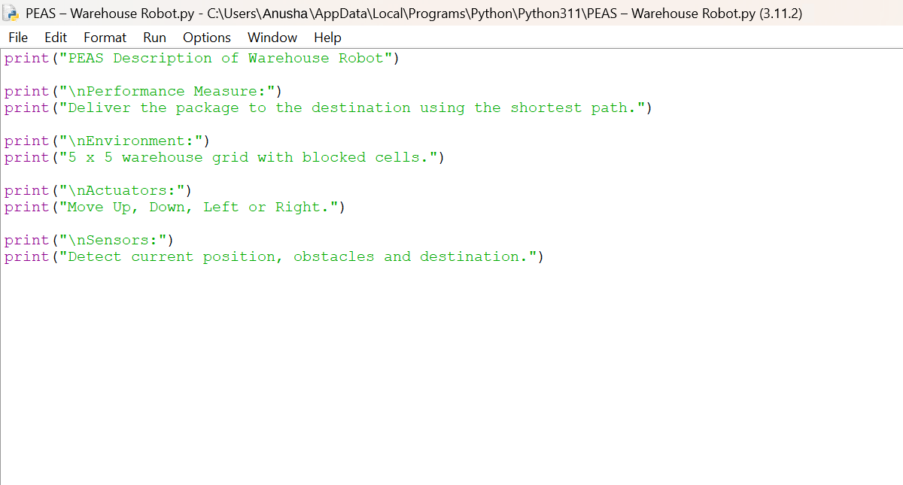
Input:
Output:
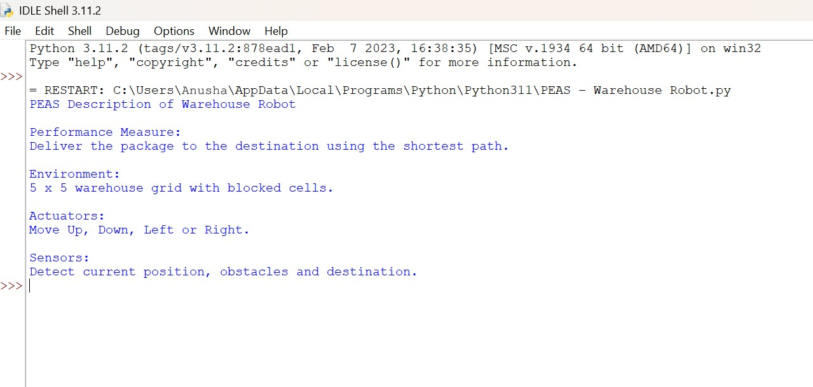

Type of Agent: Goal-Based Agent
A goal-based agent (that also keeps a model of the map) is the best fit, for these reasons:
  - Simple reflex is unsuitable: it reacts only to the current cell. The map contains dead ends, for example (3,2) and (4,3), which a reflex rule such as “move toward (5,5)” would walk into and could oscillate between.
  - Model-based alone is not enough: it tracks the state and knows what the actions do, but has no explicit target to decide which action is better.
  - Goal-based fits: the task has one explicit goal, (5,5). The agent knows the map and the effect of each move, so it can search ahead, find a complete sequence of moves, and avoid dead ends before moving.
  - Utility-based is unnecessary: all moves cost 1 and there is a single objective, so there is no trade-off (risk, energy, congestion) to weigh. It would become appropriate if aisles had different costs or the robot had to balance speed against safety.

Input:

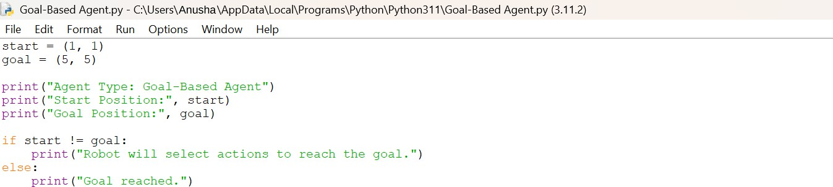

Output:
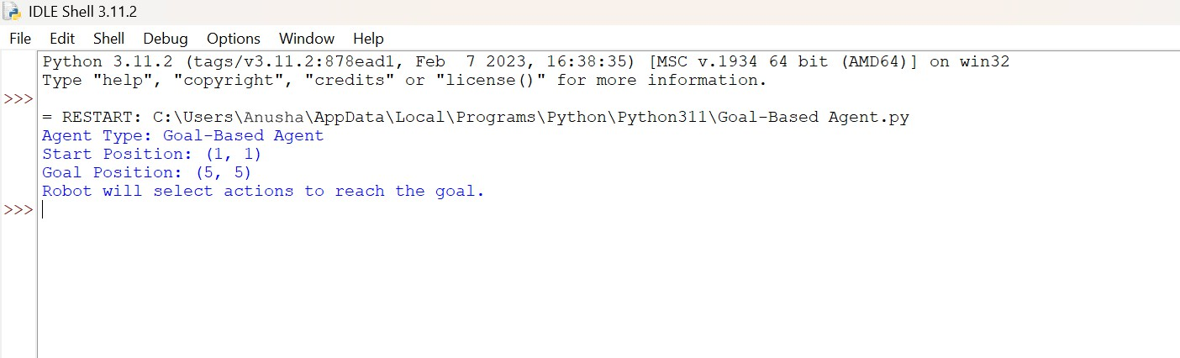

Formal Search Problem Definition

Element | Definition
State space | All cells (r, c) with 1 ≤ r, c ≤ 5 that are not blocked (20 states).
Initial state | (1,1)
Goal state | (5,5). Goal test: state = (5,5).
Actions | ACTIONS(r,c) = the subset of {Up, Down, Left, Right} whose resulting cell is inside the grid and not blocked.
Transition model | RESULT((r,c), Up) = (r−1, c)  RESULT((r,c), Down) = (r+1, c)  RESULT((r,c), Left) = (r, c−1)  RESULT((r,c), Right) = (r, c+1)  (only if the resulting cell is legal; otherwise the action is not available)
Path cost | Step cost c(s, a, s′) = 1 for every move, so g(path) = number of moves.

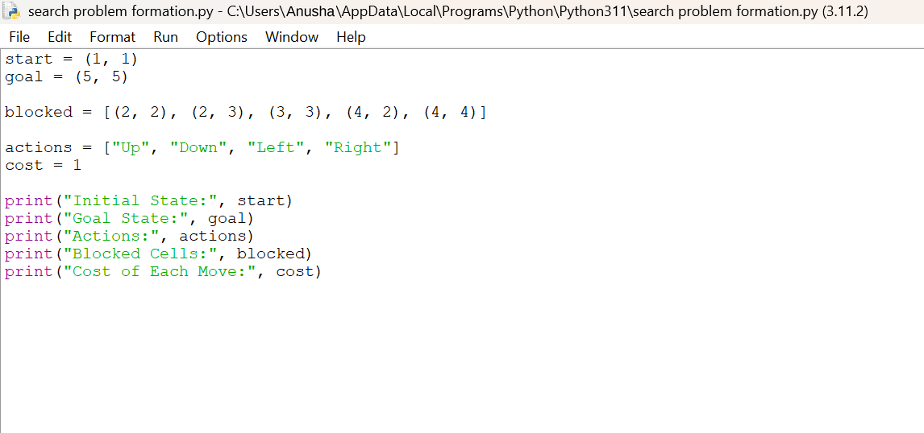
Input:

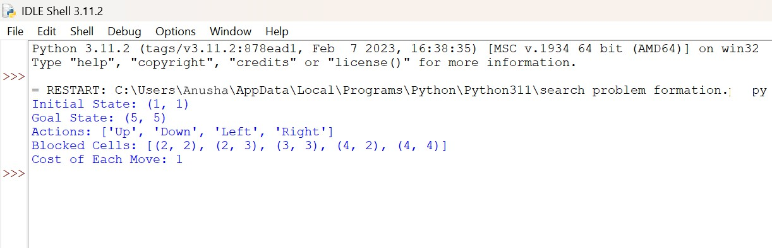
Output:

- Breadth-First Search (BFS)
BFS uses a FIFO queue. The goal test is applied when a node is generated. “Children added” lists only unvisited cells. Frontier is shown front → back.

Step | Node expanded | Children added | Frontier (queue) after step
0 | – | – | (1,1)
1 | (1,1) | (2,1), (1,2) | (2,1), (1,2)
2 | (2,1) | (3,1) | (1,2), (3,1)
3 | (1,2) | (1,3) | (3,1), (1,3)
4 | (3,1) | (4,1), (3,2) | (1,3), (4,1), (3,2)
5 | (1,3) | (1,4) | (4,1), (3,2), (1,4)
6 | (4,1) | (5,1) | (3,2), (1,4), (5,1)
7 | (3,2) | none (dead end) | (1,4), (5,1)
8 | (1,4) | (2,4), (1,5) | (5,1), (2,4), (1,5)
9 | (5,1) | (5,2) | (2,4), (1,5), (5,2)
10 | (2,4) | (3,4), (2,5) | (1,5), (5,2), (3,4), (2,5)
11 | (1,5) | none ((2,5) already queued) | (5,2), (3,4), (2,5)
12 | (5,2) | (5,3) | (3,4), (2,5), (5,3)
13 | (3,4) | (3,5) | (2,5), (5,3), (3,5)
14 | (2,5) | none ((3,5) already queued) | (5,3), (3,5)
15 | (5,3) | (4,3), (5,4) | (3,5), (4,3), (5,4)
16 | (3,5) | (4,5) | (4,3), (5,4), (4,5)
17 | (4,3) | none (dead end) | (5,4), (4,5)
18 | (5,4) | (5,5) = GOAL | Goal generated, stop

Result: Path = (1,1) → (2,1) → (3,1) → (4,1) → (5,1) → (5,2) → (5,3) → (5,4) →
(5,5). Total cost = 8 (8 moves, depth 8). Nodes expanded = 18; maximum frontier
size = 4.
Other cost-8 paths exist (for example along the top row and right column); which one BFS returns depends only on the tie-breaking order. BFS is guaranteed to return a cost-8 path, which is the minimum because the Manhattan distance from (1,1) to (5,5) is 8.

input:

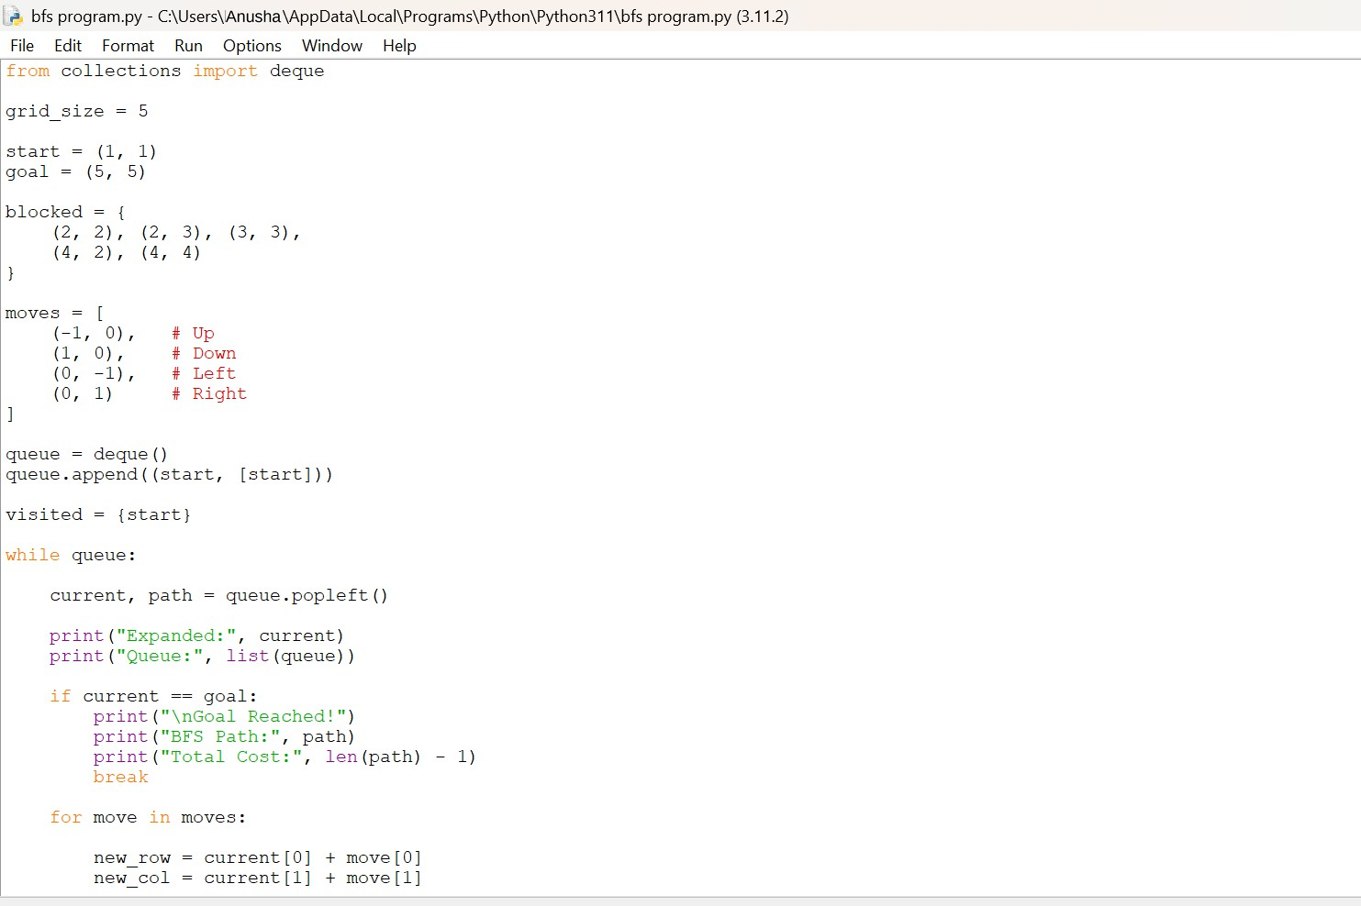

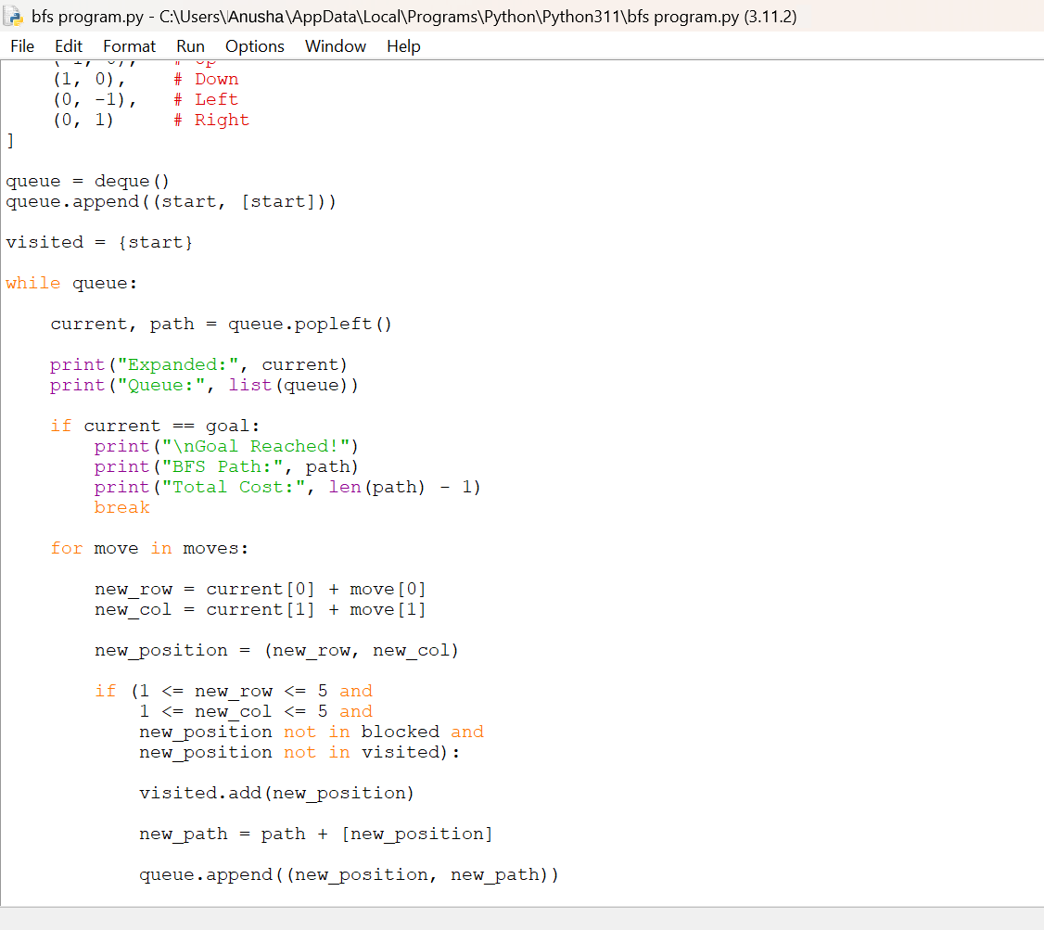

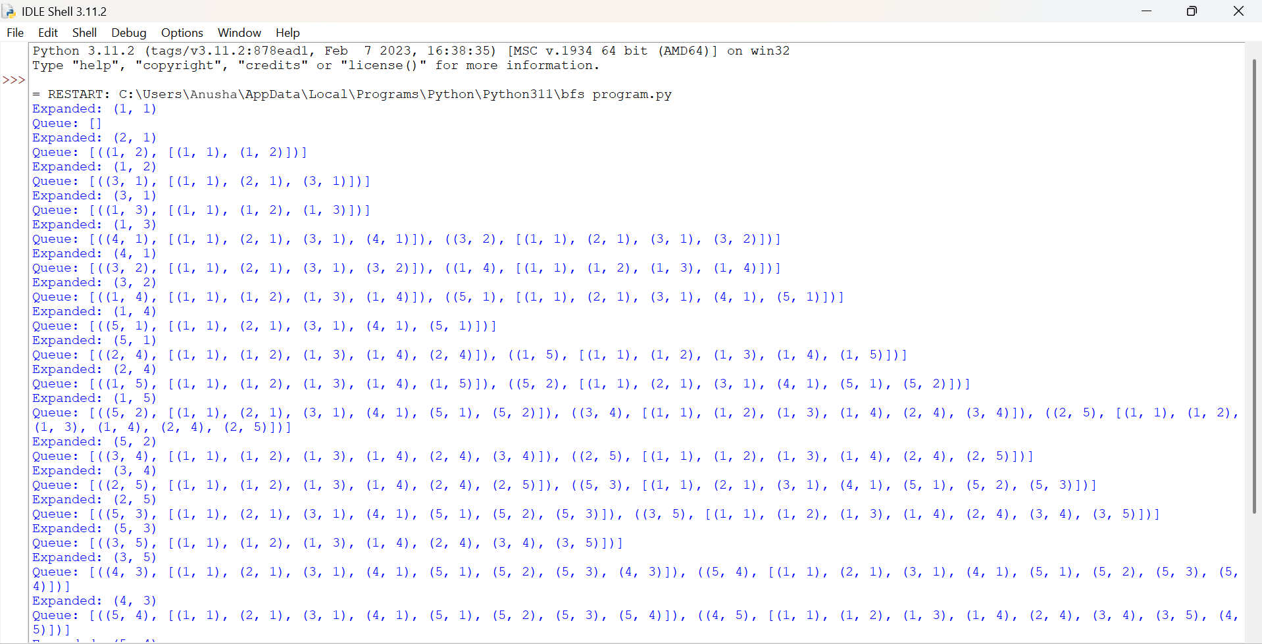
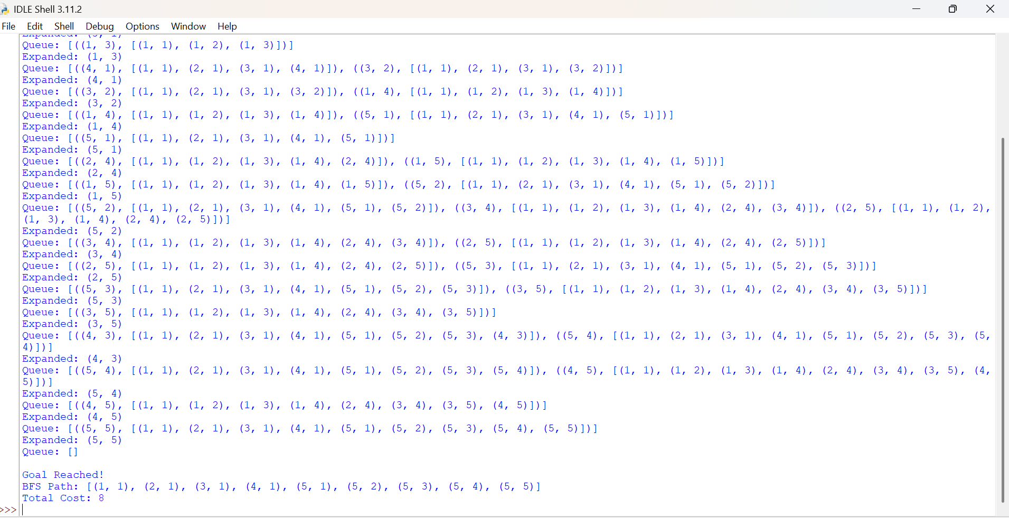
Output (BFS):

- Depth-First Search (DFS)
DFS uses a LIFO stack, with an explored set. Neighbours are pushed so that the first one in the order Up, Down, Left, Right is on top and is popped first. The goal test is applied when a node is popped. The stack is shown top → bottom.

Step | Node popped | Children pushed | Stack after step (top → bottom)
0 | – | – | (1,1)
1 | (1,1) | (2,1), (1,2) | (2,1), (1,2)
2 | (2,1) | (3,1) | (3,1), (1,2)
3 | (3,1) | (4,1), (3,2) | (4,1), (3,2), (1,2)
4 | (4,1) | (5,1) | (5,1), (3,2), (1,2)
5 | (5,1) | (5,2) | (5,2), (3,2), (1,2)
6 | (5,2) | (5,3) | (5,3), (3,2), (1,2)
7 | (5,3) | (4,3), (5,4) | (4,3), (5,4), (3,2), (1,2)
8 | (4,3) | none (dead end, backtrack) | (5,4), (3,2), (1,2)
9 | (5,4) | (5,5) | (5,5), (3,2), (1,2)
10 | (5,5) = GOAL | – | Goal popped, stop ((3,2), (1,2) left unexplored)

Result: Path = (1,1) → (2,1) → (3,1) → (4,1) → (5,1) → (5,2) → (5,3) → (5,4) →
(5,5). Total cost = 8. Nodes expanded = 9 (the goal is popped on step 10); maximum stack size = 4.
Note: DFS reached an optimal path here only because of the chosen order. If the order is changed to Right, Left, Down, Up, DFS returns the longer path (1,1) → (1,2)
→ (1,3) → (1,4) → (1,5) → (2,5) → (2,4) → (3,4) → (3,5) → (4,5) → (5,5) with cost
10. DFS gives no guarantee of the shortest path.

Input:

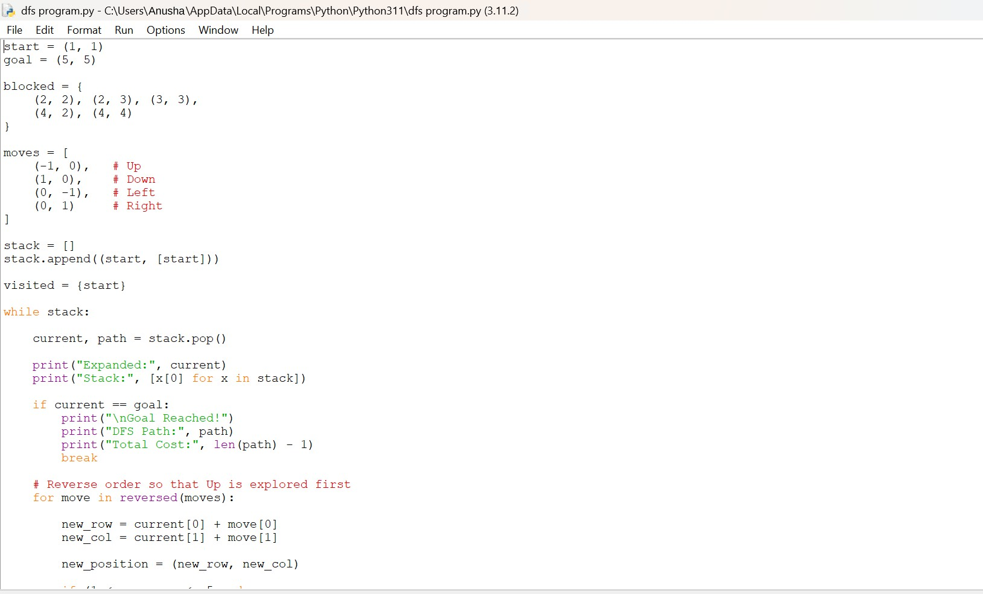
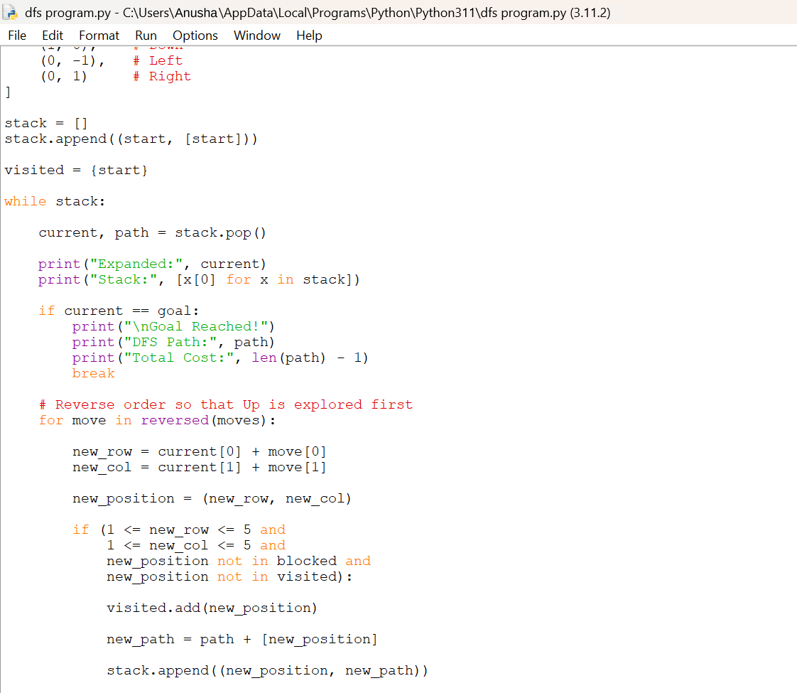

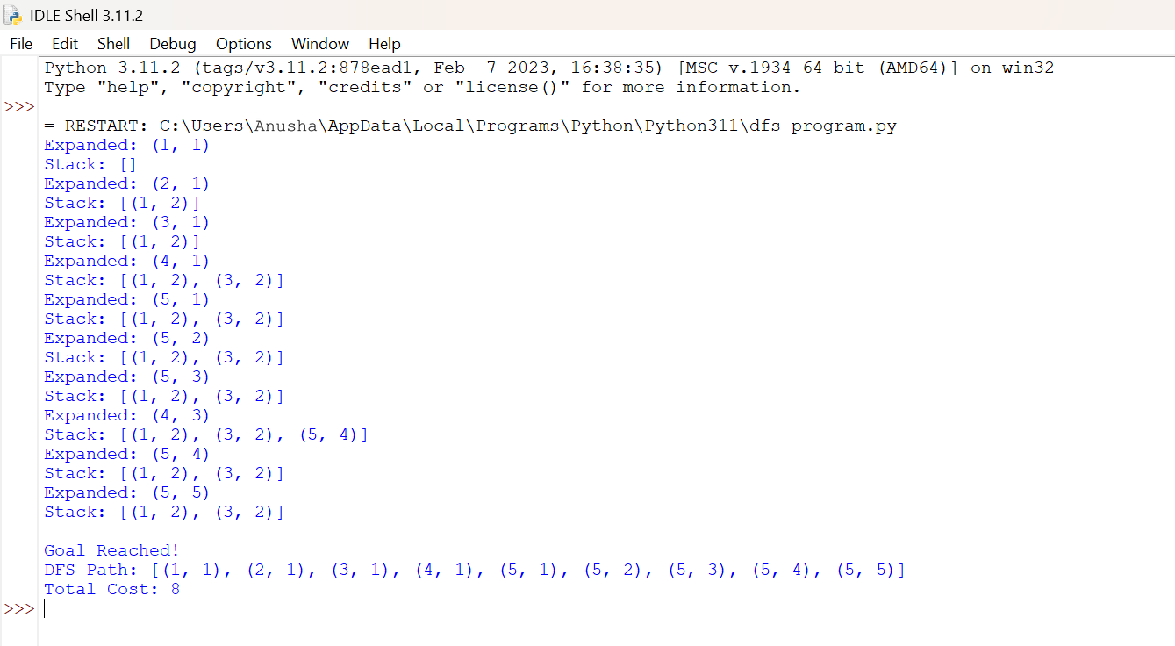
output:

- Comparison of BFS and DFS
Let b = branching factor (at most 4, effectively about 2–3 here), d = depth of the shallowest goal (8), m = maximum depth of the search tree, and V = number of states (20).

Criterion | BFS | DFS
Completeness | Complete: finite state space and finite branching factor, so it always finds a solution if one exists. | Complete only with an explored set (cycle checking) in a finite space. Plain tree search can loop forever, e.g. (1,1) ↔ (2,1).
Optimality | Optimal, because every step costs 1: it finds the shallowest goal, which is the cheapest path (cost 8). | Not optimal: returns the first path found, which can be longer (cost 10 with a different move order).
Time complexity | O(b^d) for tree search, O(V + E) for graph search. Here: 18 nodes expanded. | O(b^m) for tree search, O(V + E) for graph search. Here: 9 nodes expanded (fast because of a favourable order).
Space complexity | O(b^d): the whole frontier is stored. Here: maximum frontier size 4. | O(b·m) for tree search with path checking; O(V) with an explored set. Here: maximum stack size 4.

Conclusion: BFS is more suitable for this warehouse delivery problem.
  - The robot should use the fewest moves (least time and energy). BFS guarantees the minimum cost of 8 for every move ordering, whereas DFS can return a path of cost 10 or more.
  - The grid has only 20 states, so BFS's larger memory use is not a concern. DFS's main advantage (small memory) does not matter here.
  - For much larger warehouses, memory and time would grow, and an informed search such as A* with the Manhattan-distance heuristic (admissible here) would be the natural upgrade while keeping optimality.

Input:

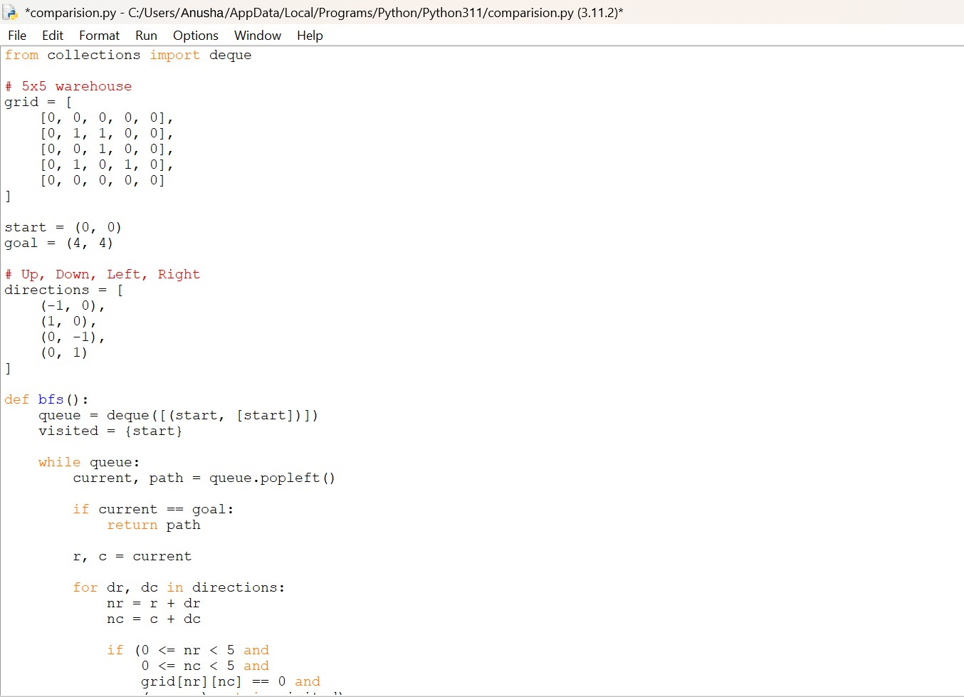
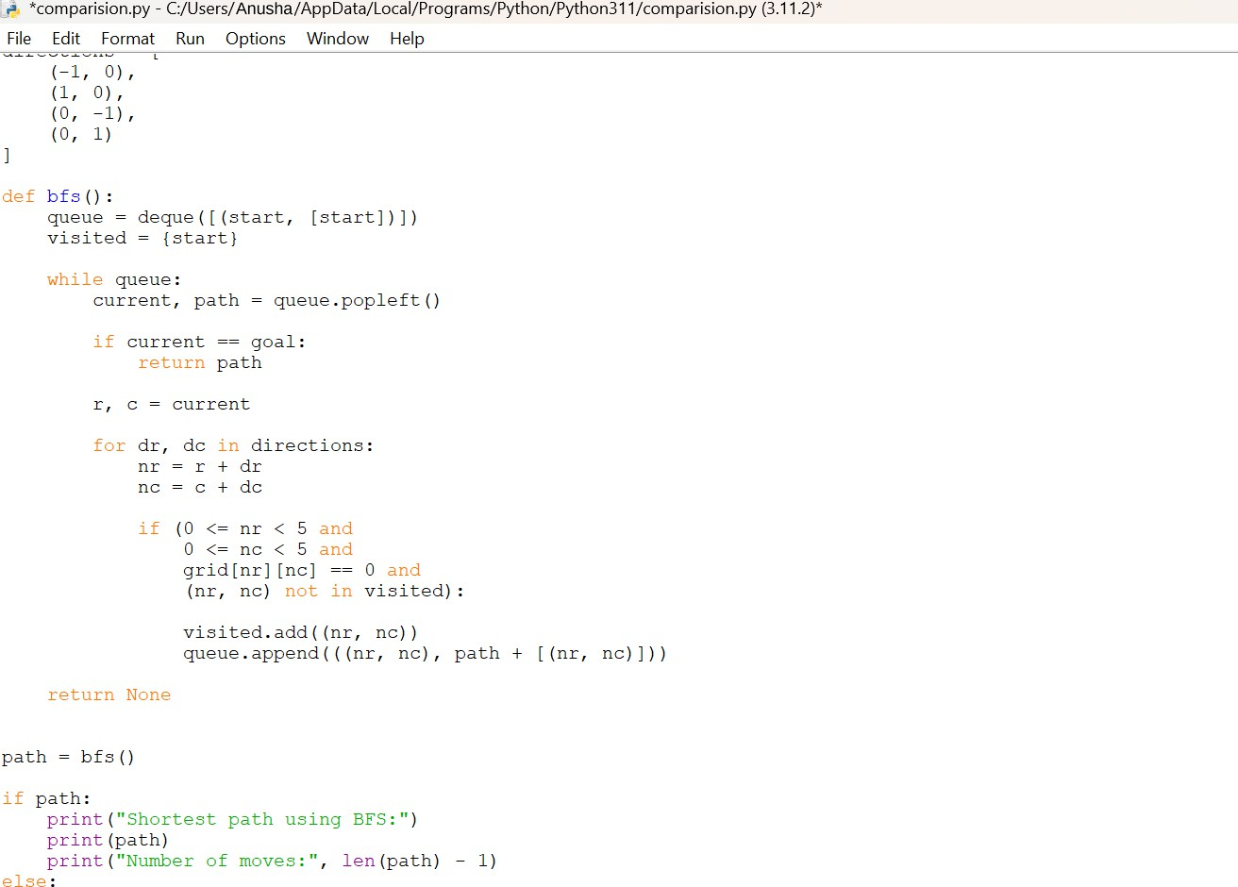

Output:
